**CS553 PROJECT REPORT**

**Understanding the Cost of Computing in the Cloud**

Ahsan Burney

CWID: A20389603

Mohd Sadique

CWID: A20380442

**Abstract**

The main goal of this project is to find the comparison between the self-created private cloud instances and public cloud instances. We are provided with the problem statement that is described below. Based on this problem statement for different configurations we are to find the results and compare them.

To further explain what a public cloud is to have a better idea is that. The public cloud is defined as a multi-tenant environment, where you buy a “server slice” in a cloud computing environment that is shared with a number of other clients or tenants.

Private cloud by definition is a single-tenant environment where the hardware, storage and network are dedicated to a single client or company.

**Problem Statement:**

You are hired by a startup company who is considering using cloud computing instead of building its own infrastructure. There is consensus that a cloud computing software stack at the layer of IaaS will be used, but it’s not clear whether the computing resources should be rented from a public cloud on-demand, or whether a private cloud should be purchased. You are tasked to find the cost breakdown of a private cloud, and compare that to what Amazon would charge. You can find many instance types defined at <http://aws.amazon.com/ec2/instance-types/>, and their prices are set at <http://aws.amazon.com/ec2/pricing/>.

For pricing purposes, please stick to Linux on demand pricing. Since you have to estimate the cost of the hardware when building a private cloud, you can use hardware prices found at Dell <http://www.dell.com/p/enterprise-products.aspx?c=ae&l=en&s=bsd&~ck=mn> AcmeMicro <http://www.acmemicro.com> , or Pogolinux <http://www.pogolinux.com> as good sources for server hardware. If you cannot find some particular hardware here, please cite whatever site you find where you obtained the pricing information. You must include a printout of your shopping cart in your final write-up report for this assignment; include this as an appendix at the end of your report.

You are to estimate the cost of different configurations for 3 different set of requirements:

• **Configuration 1:** Hadoop/Spark Cluster with 32K-cores, 256TB memory, 50PB HDD, and 10Gb/s Ethernet Fat-Tree network (each VM should be equivalent to the d2.8xlarge instance); in addition to the compute resources, a 100PB distributed storage shared across the entire cloud should be procured, with enough capacity for 100GB/sec throughput (for pricing comparison, see S3)

• **Configuration 2:**  Support 1 million virtual machines (VM) where each VM requires 2-core, 15GB RAM, 32GB SSD storage, and 1Gb/s Fat-Tree network (each VM should be equivalent to the r3.large instances); in addition to the compute resources, a 10PB distributed storage shared across the entire cloud should be procured, with enough capacity for 10GB/sec throughput (for pricing comparison, see S3)

• **Configuration 3:** Support deep learning with 1 exaflop of mixed precision performance (hint: each VM should be equivalent to p3.16xlarge instances; you will want to use the NVIDIA V100 GPUs (8 GPUs per node), and allocate 8-cores per GPU (64-cores per node) with 8GB of memory per core (512GB per node); the network to use is at least 10Gb/s per GPU (100Gb/s should work), and should be organized in a Fat-Tree network; in addition to the compute resources, a 1PB distributed storage shared across the entire cloud should be procured, with enough capacity for 10GB/sec throughput (for pricing comparison, see S3)

**PUBLIC CLOUD (AMAZON EC2) COST Calculation for Configuration 1**

**Configuration 1**

Hadoop/Spark Cluster with 32K-cores, 256TB memory, 50PB HDD, and 10Gb/s Ethernet Fat-Tree network (each VM should be equivalent to the d2.8xlarge instance)

In addition to the compute resources, a 100PB distributed storage shared across the entire cloud should be procured, with enough capacity for 100GB/sec throughput (for pricing comparison, see S3)

**D2 – Dense-storage Instances**

D2 instances feature up to 48 TB of HDD-based local storage, deliver high disk throughput, and offer the lowest price per disk throughput performance on Amazon EC2.

Features:

* High-frequency Intel Xeon E5-2676 v3 (Haswell) processors
* HDD storage
* Consistent high performance at launch time
* High disk throughput
* Support for Enhanced Networking

According to our problem Statement we need to use **d2.8xlarge Model**

**Cost of AWS d2.8xlarge instance** = $5.52/hour

|  |  |  |  |  |  |  |  |
| --- | --- | --- | --- | --- | --- | --- | --- |
| **Amazon EC2 Instances** | | | | | | | |
| **Instance Type** | **vCPU** | **Mem (GiB)** | **Storage (GB)** | **Networking Performance** | **Physical CPU** | **Clock Speed (GHz)** | **Linux**  **On Demand** |
| **d2.8xlarge** | **36** | **244** | **24 x 2000** | **10 Gigabit** | **Intel Xeon E52676 v3** | **2.4** | **$5.52/Hour** |

In Configuration 1 we need to use 32K core,256 TB Memory ,50PB HDD, and 10Gb/s Ethernet Fat-Tree network (each VM should be equivalent to the d2.8xlarge instance);

In addition to the compute resources, a 100PB distributed storage shared across the entire cloud should be procured, with enough capacity for 100GB/sec throughput (for pricing comparison, see S3)

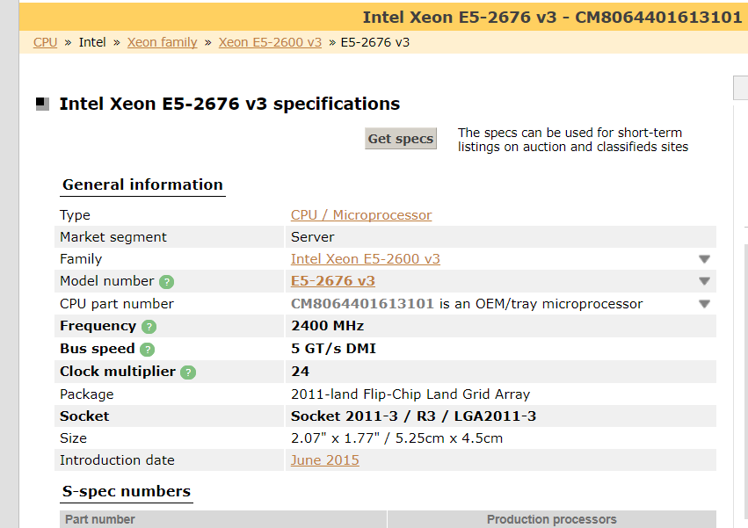

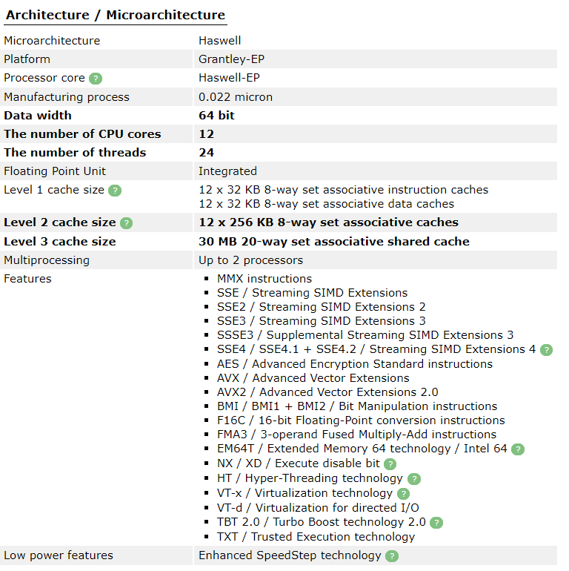

<http://www.cpu-world.com/CPUs/Xeon/Intel-Xeon%20E5-2676%20v3.html>

**Amazon d2.8xlarge price for 1 Instance = 5.52$/hr**

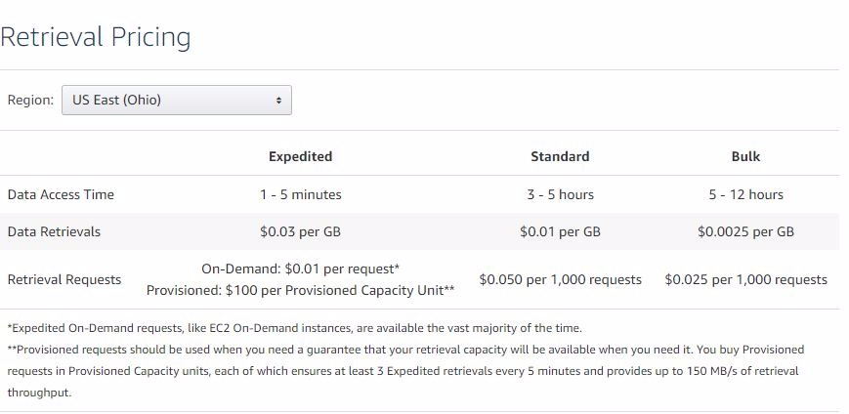

Total Cost Estimation of 5 years: = 32k Instance + 100PB Memory + 100PB data Transfer

=

= **$245817050.4**

#### Private Cloud:

|  |  |  |  |  |
| --- | --- | --- | --- | --- |
|  | Description | Price per Item | Quantity | Total Price |
| Compute Servers | 2 proc, 32GB x6 RAM, 4TB HDD, N/W adaptor, Motherboard, Chassis | $8476.49 | 1334 | $11307637.66 |
| Network Switches | CISCO SG500X-48-K9-NA SG500X-48 Layer 3 Switch | $22835 | 475 | $5959935 |
| Racks | 5U 4 Post Open Frame Rack | $156 | 89 | $13884 |
| Storage Servers | Digiliant R1S108LS-NW-0020 2TB Windows Storage Server |  | 6250 | $ 57968750 |
| Electric Power |  | $.137 |  | $20711918.43 |
| Cooling |  | $.137 | 51909570kW | $ |
| Administration | 5years | $100,000 | 10*5 | $5,000,000 |
| TOTAL | **$** **107866097.9** | | | |

##### Computer Server:

|  |  |  |  |  |
| --- | --- | --- | --- | --- |
| Component | Details | Cost | Qty | Total Cost |
| Processor | Intel Xeon E5-2676 v3 (Haswell) processors | $2,893 | 2 | $5,786 |
| RAM | SNPCC9FNC/32G - Dell Compatible 32GB PC3-10600 DDR3-1333Mhz 4Rx4 1.35v ECC Registered RDIMM | $360 | 6 | $2,160 |
| HDD | Seagate Technology ST4000DM005 4TB BarraCuda SATA 6GB 64MB Cache 3.5-Inch Internal Hard Drive | $130 | 1 | $130 |
| Network Adaptor | StarTech ST1000BT32 1 Port PCI 10/100/1000 32 Bit Gigabit Ethernet Network Adapter Card | $10.49 | 1 | $10.49 |
| Chasis | Rosewill RSV-L4500 - 4U Rackmount Server Case or Chassis - 15 Internal Bays, 8 Cooling Fans Included | $110 | 1 | $110 |
| Motherboard | Supermicro Dual LGA2011, Intel C612, DDR4, SATA3 & USB3.0, A & 2GbE, ATX Server Motherboard X10DAL-I-O | $280 | 1 | $280 |
| UPS | APC SMC 1500 1440VA 900W UPS 8ports | $332 | 1 | $332 |

**Total Server Price = $8476.49**

**Network Switch:**

**Note: For formulae refer [1]**

For FAT tree network with a Switch of 32 ports [1], we can have maximum of,

##### **Racks:**

##### **Storage Servers:**

**Network Cables:**

**Electric Power:**

Note: *Refer****[1]*** *for Description on Power consumption*

On an average, a server with 2 intel Xeon processor consumes approximately 0.5 – 2.0 amps and 200-450 watts per hour.

**So we Considering for 100% utilization power consumption = 450W**

**Cooling Power:**

#### Comparison between AWS and Private cloud for Configuration 1:

We estimated for Configuration 1 with AWS we need **$245,817,050.4**and if we build our own datacentre we will be needing **$** **105951550,** which is far more less then compare to Amazon Public cloud.

**Per year cost comparison for Public v/s Private cost.**

|  |  |  |
| --- | --- | --- |
| **Years** | **Public Cost(AWS)** | **Private Cost** |
| 1 | 49163410.08 | 81773384.91 |
| 2 | 98326820.16 | 88296563.16 |
| 3 | 147490230.2 | 94819741.4 |
| 4 | 196653640.3 | 101342919.7 |
| 5 | 245817050.4 | 107866097.9 |

**From the above graph It can be easily concluded , if the requirement was for 1 year then Public Cloud (AWS) must have been a very good choice, however for a long term we have to go for Private cloud.**

**Note: Even we take 2% of Damage cost over 5 years then number is so big with AWS that it won’t affect the decision that one will opt for Private Cloud.**

**Configuration 2**

Support 1 million virtual machines (VM) where each VM requires 2-core, 15GB RAM, 32GB SSD storage, and 1Gb/s Fat-Tree network (each VM should be equivalent to the r3.large instances); in addition to the compute resources, a 10PB distributed storage shared across the entire cloud should be procured, with enough capacity for 10GB/sec throughput (for pricing comparison, see S3)

**Public Cloud**

## R3.large

R3 instances are optimized for memory-intensive applications and offer lower price per GiB of RAM.

Features:

* High Frequency Intel Xeon E5-2670 v2 (Ivy Bridge) Processors
* Ram Memory : 15.25 GiB
* vCPU :2
* vCore :1
* Support for [Enhanced Networking](https://aws.amazon.com/ec2/faqs/#What_networking_capabilities_are_included_in_this_feature)

According to our problem Statement we need to use r3.large Model

|  |  |  |  |  |  |  |  |
| --- | --- | --- | --- | --- | --- | --- | --- |
| **Amazon EC2 Instances** | | | | | | | |
| **Instance Type** | **vCPU** | **Mem (GiB)** | **Storage (GB)** | **Networking Performance** | **Physical CPU** | **Clock Speed (GHz)** | **Linux**  **On Demand** |
| r3.large | 2 | 15.25 | 1 x 32 SSD | Moderate | Intel Xeon E5-2670 v2 | 2.5 | $0.166/hour |

**In Configuration 2 we need to use 1 million virtual machines (VM) where each VM requires 2-core, 15GB RAM, 32GB SSD storage, and 1Gb/s Fat-Tree network**

**Computing these values from above table we get**

**Estimation of 5 years:**

10PB distributed storage shared across the entire cloud:-

Cost of 1

Cost for 10PB distributed storage shared across the entire cloud S3(Glacier):

10 * 1024 * 1024 * 0.004 = $41943.04 / Month

5 Years Cost of S3 = 5 * 12 * 41943.04 = **$2,516,582.4**

Data Transfer Pricing (OUT from Amazon s3): 10 * 1024 * 1024 * 0.010 = **$104,857.6**

**PRIVATE CLOUD COST Calculation for Configuration 2**

#### PRIVATE CLOUD:

|  |  |  |  |  |
| --- | --- | --- | --- | --- |
|  | Description | Price per Item | Qty | Total Price |
| Compute Servers | 2 proc, 32GB x5 RAM, 240GB SSD + 120GB SSD, N/W adaptor, Motherboard, Chassis  20 cores ( 10 2-core with 15GB ram) | $5592.44 | 100000 | $559,240,000 |
| Network Switches | Lenovo G7052 Ethernet Switch - 48 Ports | $1723.92 | 4194 | $7,226,262 |
| Network Cables | CAT 7E Internet Ethernet LAN Network Cable 10Ft 3M 10 Gbps Super Speed SSTP Shielded Patch Shielded | $17.28 |  | $14778447.36 |
| Racks | 5U 4 Post Open Frame Rack | $156 | 7450 | $111750 |
| Storage Servers | Digiliant R1S108LS-NW-0020 2TB Windows Storage Server | $4,412 | 625 | $5796875 |
| Electric Power | Comed | $0.15 | 2065982490KW | $274775671.2 |
| Cooling | Comed | $0.15 | 1/3 | $91591890.4 |
| Administration | 1 admin per 1000 Servers | $100000 | 100 * 5(years ) | $50,000,000 |
| TOTAL | **$****1,003,520,896** | | | |

|  |  |  |  |  |
| --- | --- | --- | --- | --- |
| Component | Details | Cost | Qty | Total Cost |
| Processor | Intel Xeon E5-2670 v2 2.50 GHz Processor - Socket FCLGA2011 BX80635E52670V2 - 10 Core | $1,538.90 | 2 | $3076 |
| RAM 150 GB | SNPCC9FNC/32G - Dell Compatible 32GB PC3-10600 DDR3-1333Mhz 4Rx4 1.35v ECC Registered RDIMM | $360 | 5 | $1800 |
| SSD 240GB + 120 GB | PNY CS1311 240GB 2.5” SATA III Internal Solid State Drive (SSD) - (SSD7CS1311-240-RB) | $69.97(240 GB) | 1 | 119.96 |
| $49.99(120 GB) |
| Network Adaptor | StarTech ST1000BT32 1 Port PCI 10/100/1000 32 Bit Gigabit Ethernet Network Adapter Card | $10.49 | 1 | $10.49 |
| Chasis | Rosewill RSV-L4500 - 4U Rackmount Server Case or Chassis - 15 Internal Bays, 8 Cooling Fans Included | $110 | 1 | $110 |
| Motherboard | ASRock Rack EP2C612D24-4L Dual LGA2011-v3/ Intel C612/ DDR4/ SATA3&USB3.0/ M.2/ V&4GbE/ SSI EEB Server Motherboard **Supports 4 – 22 Core (link5)** | $475.99 | 1 | $475.99 |
| UPS |  |  |  |  |

**Total 1 Server price = $5592.44**

##### Network Switch:

**Total Switches = 4194**

##### Network Cables:

Considering 20ft per server to connect to switches,

So we need 20 x 100000→ 2000000 ft

For Distributed Storage, again considering 15ft per server to connect to switches,

So we need 625 x 20 → 12500 ft

Total, we need 2012500, Cost per 10 ft is $17.28 → **$3477600**

##### Racks:

In 1 rack we can place 15 Servers,

So, for servers we need 100000/15 racks = 6667 Racks

For Distributed Storage we need 625/15 → 42 Racks

Total, we need **7450** Racks

##### Storage Servers:

1 storage server we can have 2TB x 8 SSD, 16TB SSD.

Cost of 2TB SSD is $700.

Cost of 1 storage box is $3675

So, for 10PB storage we need 625 Storage box with each box consisting of 16TB SSD.

So, total Cost per storage box will be,

$700 x 8 + $3675 → **$9275**

##### Electric Power:

Note: *Refer[ 1****]*** *for Description on Power consumption*

*On an average, a server with 2 intel Xeon processor consumes approximately 0.5 – 2.0 amps and 200-450 watts per hour.*

*So we Considering for 100% utilization power consumption = 450W*

2065982490

274775671.2

**Cooling Power:**

#### Comparison between AWS and Private cloud for Configuration 2:

We estimated for Configuration 1 with AWS we need **$** and if we build our own datacentre we will be needing **$1,003,520,896,** which is far more less then compare to Amazon Public cloud.

**We can easily conclude from the above graph, For Configuration 2, one should always go for Private cloud.**

**Note: Even we take 2% of Damage cost the number is so big with AWS that it won’t affect the decision that one will opt for Private Cloud.**

**Configuration 3**

Support deep learning with 1 exaflop of mixed precision performance (hint: each VM should be equivalent to p3.16xlarge instances; you will want to use the NVIDIA V100 GPUs (8 GPUs per node), and allocate 8-cores per GPU (64-cores per node) with 8GB of memory per core (512GB per node); the network to use is at least 10Gb/s per GPU (100Gb/s should work), and should be organized in a Fat-Tree network; in addition to the compute resources, a 1PB distributed storage shared across the entire cloud should be procured, with enough capacity for 10GB/sec throughput (for pricing comparison, see S3)

## P3.16xlarge

## 

Amazon EC2 P3.16xlarge instances are the next generation of Amazon EC2 GPU compute instances that are powerful and scalable to provide GPU-based parallel compute capabilities.

P3 instances are ideal for computationally challenging applications, including machine learning, high-performance computing, computational fluid dynamics, computational finance, seismic analysis, molecular modeling, genomics, and development of autonomous vehicle systems.

|  |  |  |  |  |  |  |  |
| --- | --- | --- | --- | --- | --- | --- | --- |
| **Instance Type** | **vCPU** | **Mem (GiB)** | **Storage (GB)** | **GPU** | **GPU Memory (GB)** | **Physical CPU** | **Linux** |
| **On Demand** |
| p3.16xlarge | 64 | 488 | EBS | **GPUS-Tesla v100-8** | 128 | Intel Xeon E5-2686 v4 | $24.48/hour |
|

Requirement : 1 exaflops cluster network

P3.16xlarge provides 125 Tflops of mixed-precision performance.

Total core Counts = 1 ExaFlops / 125 Tflops = 8000 GPU

Estimation of 5 years:

**PRIVATE CLOUD COST Calculation for Configuration 3**

|  |  |  |  |  |
| --- | --- | --- | --- | --- |
|  | Description | Price per Item | Qty | Total Price |
| Compute Servers | 2 proc, 2 GPU, 32GB x3 RAM + 64GB RAM, N/W adaptor, Motherboard, Chassis | $45942.22 | 4000 | $183,768,880 |
| Network Switches | Lenovo G7052 Ethernet Switch - 48 Ports | $1723.92 | 170 | $293,066.4 |
| Network Cables | CAT 7E Internet Ethernet LAN Network Cable 10Ft 3M 10 Gbps Super Speed SSTP Shielded Patch Shielded | $17.28 | 60945 ft | $ |
| Racks | 5U 4 Post Open Frame Rack | $156 | 272 | $42432 |
| Storage Servers | R1S108LS-NW | $9275 | 63 | $584325 |
| Electric Power |  | $.137 | KW | $ |
| Cooling |  | $.137 | 187276755kW | $ |
| Administration | Description given below | $100000 | 5(per Server) * 5 years | $2,500,000 |
| Total |  |  |  | $221,542,006.1 |

|  |  |  |  |  |
| --- | --- | --- | --- | --- |
| Component | Details | Cost | Qty | Total Cost |
| Processor | Intel Xeon E5-2687W v4 3.0GHz,30M Cache,9.60GT/s QPI,Turbo,HT,12C/24T (160W) Max Mem 2400MHz,processor only,Customer Kit | $ 3,099.99 | 2 | $6,198 |
| GPU | NVIDIA Tesla V100 GPUs | $18625 | 2 | $37,250 |
| RAM | SNPCC9FNC/32G - Dell Compatible 32GB PC3-10600 DDR3-1333Mhz 4Rx4 1.35v ECC Registered RDIMM | 32GB ($351) x1 + 64GB ($719)*2 | 6 | $1,789 |
| Network Adaptor | StarTech ST1000BT32 1 Port PCI 10/100/1000 32 Bit Gigabit Ethernet Network Adapter Card | $10.49 | 1 | $10.49 |
| Chasis | Rosewill RSV-L4500 - 4U Rackmount Server Case or Chassis - 15 Internal Bays, 8 Cooling Fans Included | $110 | 1 | $110 |
| Motherboard | Supermicro Dual LGA2011, Intel C612, DDR4, SATA3 & USB3.0, A & 2GbE, ATX Server Motherboard X10DAL-I-O | $252.73 | 1 | $252.73 |
| UPS | APC SMC 1500 1440VA 900W UPS 8ports | $332 | 1 | $332 |
| Total |  |  |  | **$****45942.22** |

##### **Network Switch:**

##### Network Cables:

##### **Storage Servers:**

**Network Cables:**

**Electric Power:**

On an average, a server with 2 intel Xeon processor consumes approximately 0.5 – 2.0 amps and 200-450 watts per hour.

NVIDIA Tesla V100 GPUs power consumes(250W-300W) max (P3.16xlarge ref.4 ) = 300W

**So we Considering for 100% utilization power consumption = 450W**

**So total power consumption = 2 intel xeon processor with motherboard + 2 Nvidia tesla power consumtion = 450 + 2*300 = 1050Watt/hr**

**Cooling Power:**

#### Comparison between AWS and Private cloud for Configuration 2:

We estimated for Configuration 1 with AWS we need **$** and if we build our own datacentre we will be needing $221,542,006.1which is far more less then compare to Amazon Public cloud.

|  |  |  |
| --- | --- | --- |
| **Years** | **Public Cost(AWS)** | **Private Cost** |
| 1 | 211767246.8 | 192174630.1 |
| 2 | 423534493.6 | 199516474.2 |
| 3 | 635301740.4 | 206858318.4 |
| 4 | 847068987.2 | 214200162.5 |
| 5 | 1058836234 | 221542006.6 |

**From the above graph It can be concluded , if the requirement was for 1 year then Public Cloud (AWS) can be good choice, however for a long term we have to go for Private cloud.**

**Note: Even we take 2% of Damage cost over 5 years then number is so big with AWS that it won’t affect the decision that one will opt for Private Cloud.**

Conclusion :

Configuration1 :

|  |  |  |
| --- | --- | --- |
| **Utilization %** | **Public Cost(AWS)** | **Private Cost** |
| 100 | 245817050.4 | 107866097.9 |
| 90 | 221235345.4 | 105104508.8 |
| 80 | 196653640.3 | 102342919.7 |
| 70 | 172071935.3 | 99581330.53 |
| 60 | 147490230.2 | 96819741.4 |
| 50 | 122908525.2 | 94058152.28 |
| 40 | 98326820.16 | 91296563.16 |
| 36.8 | 90460674.55 | 90412854.64 |
| 30 | 73745115.12 | 88534974.03 |
| 20 | 49163410.08 | 85773384.91 |
| 15 | 36872557.56 | 84392590.35 |
| 10 | 24581705.04 | 83011795.78 |
| 5 | 12290852.52 | 81631001.22 |

Configuraton 2:

|  |  |  |
| --- | --- | --- |
| **Utilization %** | **Public Cost(AWS)** | **Private Cost** |
| 100 | 7273631155 | 1003520896 |
| 90 | 6546268040 | 966884139.4 |
| 80 | 5818904924 | 930247383.3 |
| 70 | 5091541809 | 893610627.1 |
| 60 | 4364178693 | 856973871 |
| 50 | 3636815578 | 820337114.8 |
| 40 | 2909452462 | 783700358.6 |
| 30 | 2182089347 | 747063602.5 |
| 20 | 1454726231 | 710426846.3 |
| 18.3 | 1331074501 | 704198597.8 |
| 15 | 1091044673 | 692108468.2 |
| 10 | 727363115.5 | 673790090.2 |
| 9.3 | 676447697.4 | 671225517.2 |
| 5 | 363681557.8 | 18318378.08 |

#### Configuration 3:

|  |  |  |
| --- | --- | --- |
| **Utilization %** | **Public Cost(AWS)** | **Private Cost** |
| 100 | 1058836234 | 221542006.6 |
| 90 | 952952610.6 | 218121084.5 |
| 80 | 847068987.2 | 214700162.5 |
| 70 | 741185363.8 | 211279240.4 |
| 60 | 635301740.4 | 207858318.4 |
| 50 | 529418117 | 204437396.3 |
| 40 | 423534493.6 | 201016474.2 |
| 30 | 317650870.2 | 197595552.2 |
| 20 | 211767246.8 | 194174630.1 |
| 18.3 | 193767030.8 | 193593073.4 |
| 15 | 158825435.1 | 192464169.1 |
| 10 | 105883623.4 | 190753708.1 |

Above table compares the costs of public and private cloud based on utilization.

Threshold value = 18.3%

#### **The above graph shows the comparison between AWS and private cloud the blue bar is the AWS cost and orange bar is the private cloud.**

#### **We can clearly see that at a utilization of 20% both cost almost the same. With the reduction of utilization percentage, the cost of AWS cloud reduces.**

**Per year cost comparison for Public v/s Private cost.**

In Private Cloud Hardware cost is same only power consumption and administrator cost varies

References

D3

1. <https://www.datacenters.com/news/infrastructure/135-data-center-power-costs-and-requirements>

<https://store.mellanox.com/products/mellanox-msn2700-cs2rc-spectrum-100gbe-1u-switch-w-cumulus-linux-32-qsfp28-ports-2-ac-psus-x86-2core-standard-depth-c2p-airflow-rail-kit-rohs6-cumulus-lice.html>

<http://www.memory4less.com/intel-2-40ghz-xeon-processor-e5-2676v3-e5-2676-v3>

<https://www.amazon.com/Cisco-SG500X-48-K9-NA-Port-Gigabit-Switch/dp/B007UQRRQC>

<https://www.amazon.com/SNPCC9FNC-32G-Compatible-DDR3-1333Mhz-Registered/dp/B075825BFC>

<https://www.newegg.com/Product/Product.aspx?Item=N82E16833114004&cm_re=network_Adapter-_-33-114-004-_-Product>

<https://www.amazon.com/Seagate-Technology-ST4000DM005-BarraCuda-3-5-Inch/dp/B01LZ5PED5/ref=sr_1_fkmr0_3?s=electronics&ie=UTF8&qid=1511381730&sr=1-3-fkmr0&keywords=Seagate+BarraCuda+ST4000DM005+4TB+64MB+Cache+SATA+6.0Gb%2Fs+3.5%22+Hard+Drive+Bare+Drive>

<https://www.newegg.com/Product/Product.aspx?Item=N82E16811147164>

<https://www.amazon.com/Internet-Ethernet-Network-Cable-Shielded/dp/B01D6F0LW2>

<https://www.newegg.com/Product/Product.aspx?Item=2HT-0001-000C7>

## R3

1. <https://www.amazon.com/Intel-Xeon-E5-2670-2-50-Processor/dp/B00F42XJ3Y>
2. <https://www.amazon.com/SNPCC9FNC-32G-Compatible-DDR3-1333Mhz-Registered/dp/B075825BFC>
3. <https://www.amazon.com/PNY-CS1311-240GB-Internal-Solid/dp/B019H3B3OW>
4. <https://www.newegg.com/Product/Product.aspx?Item=N82E16813182967>
5. http://www.cpu-upgrade.com/mb-ASRock/EP2C612D24-4L.html

## P3.16xlarge

## <http://www.dell.com/en-us/shop/intel-xeon-e5-2687w-v4-30ghz30m-cache960gt-s-qpiturboht12c-24t-160w-max-mem-2400mhzprocessor-onlycustomer-kit/apd/338-bjew/processors>

## <https://www.monoprice.com/product?p_id=24252&gclid=EAIaIQobChMI-azSg6TT1wIVyLrACh1v9AR8EAYYASABEgLSV_D_BwE>

## <https://www.amazon.com/Corsair-Vengeance-64GB-Systems-Black/dp/B01ET6Y09C/ref=sr_1_1?ie=UTF8&qid=1511621293&sr=8-1&keywords=64gb+ram>

## <https://www.nvidia.com/en-us/data-center/tesla-v100/>

**ScreenShots**

